DESIGN AND ANALYSIS OF ALGORITHMS
CO2- ASSIGNMENT 1

Name: M.Pranai
Registration Number: 192525068
Course Code: CSA0617
Topic: Brute-Force and Exhaustive-Search Techniques
Submission Date: 24/10/2026

Introduction
This report investigates sorting, searching, brute-force string matching, closest-pair, convex-hull and exhaustive-search algorithms. For each problem, the input conditions are designed first, expected behaviour is stated, and operation counts are used to explain the results. Operation counts are more reliable than wall-clock time for small experiments because timing varies with hardware and system load.
Note on evidence: the tables below give reproducible operation-count results derived from the stated test inputs and algorithm definitions. Execution times should be measured on the computer used for submission. Run the included Python code and replace illustrative timing values, if added, with your own measurements.

Q1 – Sorting Under Different Data Conditions (6 Marks)

1. Prediction and test design
Selection sort performs n(n−1)/2 comparisons regardless of input order. Bubble sort with an early-stop flag and insertion sort benefit from already or nearly sorted data because they can finish with few swaps/shifts. Insertion sort is expected to be especially suitable when most values are already in order.
Test case | Input | Purpose
A – already sorted | [1, 2, 3, 4, 5, 6] | Best case for adaptive bubble sort and insertion sort
B – reverse sorted | [6, 5, 4, 3, 2, 1] | Worst-case movement for all three; stresses insertion/bubble
C – nearly sorted | [1, 2, 3, 5, 4, 6] | One local inversion; tests benefit from existing order

2. Algorithms
selection_sort(A):
for i = 0 to n-2:
min_index = i
for j = i+1 to n-1:
comparisons += 1
if A[j] < A[min_index]: min_index = j
if min_index != i: swap A[i], A[min_index]
return A
bubble_sort(A):
repeat:
swapped = false
for j = 0 to last-1:
comparisons += 1
if A[j] > A[j+1]: swap; swaps += 1; swapped = true
last -= 1
until swapped == false
return A
insertion_sort(A):
for i = 1 to n-1:
key = A[i]; j = i-1
while j >= 0 and A[j] > key:
comparisons += 1; A[j+1] = A[j]; moves += 1; j -= 1
if j >= 0: comparisons += 1
A[j+1] = key
return A

3. Operation-count results
Input condition (n=6) | Selection comparisons | Selection swaps | Bubble comparisons | Bubble swaps | Insertion key comparisons* | Insertion shifts
Already sorted | 15 | 0 | 5 | 0 | 5 | 0
Reverse sorted | 15 | 3 | 15 | 15 | 15 | 15
Nearly sorted | 15 | 1 | 9 | 1 | 6 | 1
*Insertion comparisons count comparisons between array keys; loop-bound checks are excluded. Counts can vary slightly with implementation conventions, so the convention must be stated.

4. Recommendation
Because approximately 95% of orders are already in priority order and only small batches are added, insertion sort is recommended for sorting the updated list. It can insert each new order into the existing order with relatively few shifts. Selection sort still scans the remaining suffix every pass, while bubble sort also works but generally has more overhead. If the data volume becomes very large, a production system should also consider a maintained ordered index or a library sorting routine.

Conclusion
No algorithm is best for every input. Selection sort has predictable quadratic comparisons; bubble and insertion sort can exploit existing order. The business condition strongly favours insertion sort.

Q2 – When Is Sequential Search Appropriate? (4 Marks)

Experiment design
Use a list of n tool records and search for a tool ID. In a successful search, the number of comparisons is the target position (1-based). An unsuccessful search examines all n records.
List size n | First item found | Middle item found | Last item found | Not found
10 | 1 | 5 | 10 | 10
100 | 1 | 50 | 100 | 100
1000 | 1 | 500 | 1000 | 1000

Analysis and engineering boundary
Sequential search is easy to implement and appropriate for small, frequently changing lists, infrequent lookups, or when records are unsorted and maintaining an index would cost more than scanning. Its best case is O(1), while average and worst cases are O(n). As the list grows, successful searches near the end and unsuccessful searches require many comparisons.
When the organisation expands to 20 facilities, both the record count and lookup frequency may rise. If searches are frequent, sequential search should be replaced or supplemented by a hash table keyed by Tool ID (expected O(1) lookup) or a balanced search tree (O(log n) lookup). A hash table uses extra memory and requires updates when tools are issued or returned, but this is usually worthwhile for large, high-traffic datasets.

Q3 – Brute-Force String Matching (6 Marks)

Design and prediction
Test | Text | Pattern | Prediction
A – quick match | ABCDEF | AB | Very few comparisons; match at the first position
B – repeated near-match | AAAAAAAAAB | AAAAB | Many repeated comparisons before the match near the end
C – absent pattern | ABABABABAC | BABD | No match; several partial matches cause repeated comparisons

Method
for s = 0 to len(text)-len(pattern):
j = 0
while j < len(pattern) and text[s+j] == pattern[j]:
comparisons += 1
j += 1
if j < len(pattern): comparisons += 1 # first mismatch
if j == len(pattern): return s
return -1
For Test A, the pattern matches immediately, requiring 2 character comparisons. For Test B, the repeated A characters create long partial matches at many alignments; with the stated text and pattern, the algorithm performs repeated comparisons before the final match. For Test C, the pattern is absent, so every possible alignment is checked. Exact counts depend on whether a mismatch comparison is included; the code above counts every equality test, including the mismatching character.
The worst-case time complexity is O((n−m+1)m), often written O(nm), where n is text length and m is pattern length. Input size alone does not explain the work: repeated prefixes and late mismatches can cause many comparisons, while an early match may stop the search quickly.

Q4 – Closest Pair by Brute Force (6 Marks)

Algorithm and mathematical derivation
For every unordered pair of points (i,j), where i < j, compute Euclidean distance and retain the smallest distance and its pair. Restricting j to values greater than i prevents examining a pair twice. The number of unique pairs is C(n,2) = n(n−1)/2.
best_distance = infinity
for i = 0 to n-2:
for j = i+1 to n-1:
pairs_examined += 1
d = sqrt((x[i]-x[j])**2 + (y[i]-y[j])**2)
distance_calculations += 1
if d < best_distance:
best_distance = d
best_pair = (i, j)
return best_pair, best_distance
Number of drones n | Unique pairs n(n−1)/2 | Distance calculations
10 | 45 | 45
100 | 4950 | 4950
1000 | 499500 | 499500
5000 | 12497500 | 12497500

Scalability decision
For this report, an acceptable response time is defined as under 1 second on the test computer. The operation count grows quadratically: increasing n by 10 times increases pair checks by about 100 times. The exact practical threshold depends on hardware and implementation and must be confirmed by timing the program. The bottleneck is calculating the distance for every pair. A redesigned solution should reduce candidate pairs, for example by sorting points and using a divide-and-conquer closest-pair method; this assignment does not require implementing that advanced algorithm.

Q5 – Brute-Force Convex Hull (7 Marks)

Geometric rule
For candidate points A and B, compute the signed cross product for every other point P: cross = (Bx−Ax)(Py−Ay) − (By−Ay)(Px−Ax). A positive value means P lies on one side of the directed line AB, a negative value means the other side, and zero means collinear. If all points lie on one side (allowing zero), AB is a supporting boundary edge. The sign convention may be reversed without changing the idea.
edges = []
for each unordered pair (A, B):
has_positive = false; has_negative = false
for each point P other than A and B:
cross = (B.x-A.x)*(P.y-A.y) - (B.y-A.y)*(P.x-A.x)
if cross > 0: has_positive = true
if cross < 0: has_negative = true
if not (has_positive and has_negative):
add candidate edge A-B
remove duplicate edges and order the boundary points around the hull

Test configurations
- Test 1: [(0,0), (4,0), (4,4), (0,4), (2,2)]. The four corner points form the outer boundary; (2,2) is interior.
- Test 2: [(0,0), (2,1), (4,0), (3,3), (1,4), (2,2)]. This irregular configuration challenges the method with both boundary and interior points.
A useful visualisation is a scatter plot of all points with the accepted hull edges drawn as line segments. For a robust implementation, collinear points and duplicate points need special handling; the simple supporting-line test may report several collinear points along the same hull side. Deduplicate and order the extreme hull vertices to obtain a clean polygon.

Complexity and correctness
There are O(n²) candidate point pairs, and each candidate tests up to O(n) other points, giving O(n³) time. If all points lie on one side of line AB, the line is a supporting line of the point set, so segment AB lies on the convex-hull boundary (with collinear-edge handling). The method is correct in principle but inefficient for large point sets.

Q6 – Exhaustive Search and Combinatorial Growth (8 Marks)

Design
Represent each package subset by an n-bit mask: bit i is 1 when package i is selected and 0 otherwise. Enumerate every mask from 0 to 2^n−1, calculate total weight and value, reject subsets exceeding capacity, and retain the feasible subset with maximum value.
best_value = 0; best_subset = []
for mask = 0 to (1 << n)-1:
weight = 0; value = 0; chosen = []
for i = 0 to n-1:
if mask has bit i set:
weight += packages[i].weight
value += packages[i].value
chosen.append(i)
if weight <= capacity and value > best_value:
best_value = value
best_subset = chosen
return best_subset, best_value

Small correctness-check instance
Package | Weight | Value
A | 2 | 3
B | 3 | 4
C | 4 | 5
D | 5 | 8
Capacity = 8. The best feasible choice is B + D: weight 3 + 5 = 8 and value 4 + 8 = 12. A + C has weight 6 and value 8; A + B + C weighs 9 and is infeasible. Enumerating all 2^4 = 16 subsets confirms the optimum value is 12.

Growth prediction and experiment
Packages n | Subsets examined 2^n | Relative to n=10
10 | 1024 | 1×
15 | 32768 | 32×
20 | 1048576 | 1024×
25 | 33554432 | 32768×
The solution space doubles each time one package is added. This exponential growth explains why a small increase in package count can multiply the work dramatically. If the chosen response-time limit is 1 second, the deployment boundary should be set using measured throughput on the target computer; for a simple educational implementation, exhaustive search is suitable only for small n. Dynamic programming or branch-and-bound may be considered for larger instances, depending on constraints.

Q7 – Diagnose, Redesign and Validate (13 Marks)

Selected limitation: exhaustive closest-pair search
A strong redesign target is Q4 because its pair-count formula directly exposes the bottleneck. The original implementation evaluates n(n−1)/2 distances, so most work is spent in the nested pair loop. There is no duplicate pair work after restricting j > i, but the algorithm still evaluates many pairs that cannot be closest once spatial information is used.

A. Diagnose the bottleneck (2 marks)
The number of distance calculations grows quadratically: 4,950 for n=100, 499,500 for n=1,000, and 12,497,500 for n=5,000. The main limitation is examining every possible pair, not the square-root operation alone.

B. Define the design objective (2 marks)
Objective: reduce the number of distance calculations substantially as n grows, while returning the same minimum-distance pair. The correctness target is exact agreement with the brute-force answer on test datasets.

C. Revised strategy (4 marks)
Use a divide-and-conquer closest-pair design. Sort points by x-coordinate, split them into left and right halves, recursively find the closest pair in each half, and let d be the smaller distance. Examine only points in a vertical strip within distance d of the dividing line, ordered by y-coordinate; compare each strip point with only a bounded number of following points in that order. This uses preprocessing and additional memory for sorted lists/temporary arrays, but avoids checking every global pair.
closest_pair(points):
sort points by x-coordinate and by y-coordinate
return solve(points_sorted_by_x, points_sorted_by_y)
solve(Px, Py):
if number of points <= 3: use brute force
split Px into left and right halves
partition Py into corresponding left and right lists
pairL = solve(left_x, left_y)
pairR = solve(right_x, right_y)
d = min(distance(pairL), distance(pairR))
strip = points in Py within d of the split line
compare each strip point with only the next bounded number
of points in y-order
return the best pair found
Expected complexity is O(n log n) with careful sorting and strip processing, compared with O(n²) for brute force. The redesign costs extra implementation complexity and memory. Brute force can remain preferable for very small inputs because it is simpler and has low constant overhead.

D. Prediction before implementation (1 mark)
Prediction: for large point sets, the redesigned method will calculate far fewer distances and scale better than brute force. The primary metric is number of distance calculations; execution time is a secondary metric.

E. Validation plan (2 marks)
Generate identical random point sets for n = 10, 100, 1,000 and 5,000. Run both algorithms on each set, count distance calculations, and check that both return the same minimum distance (allowing a small floating-point tolerance). Record runtime on the same machine. Expected brute-force pair counts are 45, 4,950, 499,500 and 12,497,500 respectively. The divide-and-conquer implementation should show much slower growth, but actual counts and timings must be recorded from the implementation rather than invented.

F. Final design defence (2 marks)
The redesign addresses the diagnosed limitation by exploiting geometric ordering and a bounded strip comparison rather than examining every pair. It should outperform brute force for sufficiently large inputs, while requiring more code and auxiliary memory. The prediction is validated only if tests show matching answers and reduced operation counts; if small tests run faster with brute force, that is expected due to lower overhead.

Overall Conclusion
The experiments show why algorithm selection must consider input structure and growth rate. Insertion sort fits mostly ordered data; sequential search fits small or low-frequency lookups; brute-force string matching depends strongly on text-pattern structure; closest-pair brute force grows quadratically; brute-force convex hull grows cubically; and exhaustive subset search grows exponentially. The redesign process should be driven by a measured bottleneck, a specific objective, and validation against the original solution.

Appendix – Python reference implementation
def selection_sort(a):
a = a[:]; comparisons = swaps = 0
for i in range(len(a)-1):
m = i
for j in range(i+1, len(a)):
comparisons += 1
if a[j] < a[m]: m = j
if m != i:
a[i], a[m] = a[m], a[i]; swaps += 1
return a, comparisons, swaps
def bubble_sort(a):
a = a[:]; comparisons = swaps = 0; end = len(a)-1
while end > 0:
changed = False
for j in range(end):
comparisons += 1
if a[j] > a[j+1]:
a[j], a[j+1] = a[j+1], a[j]
swaps += 1; changed = True
if not changed: break
end -= 1
return a, comparisons, swaps
def insertion_sort(a):
a = a[:]; comparisons = shifts = 0
for i in range(1, len(a)):
key = a[i]; j = i-1
while j >= 0:
comparisons += 1
if a[j] > key:
a[j+1] = a[j]; shifts += 1; j -= 1
else: break
a[j+1] = key
return a, comparisons, shifts
def sequential_search(items, target):
comparisons = 0
for i, item in enumerate(items):
comparisons += 1
if item == target: return i, comparisons
return -1, comparisons
def brute_force_match(text, pattern):
comparisons = 0
for i in range(len(text)-len(pattern)+1):
j = 0
while j < len(pattern):
comparisons += 1
if text[i+j] != pattern[j]: break
j += 1
if j == len(pattern): return i, comparisons
return -1, comparisons
def closest_pair(points):
best = float('inf'); pair = None; checks = 0
for i in range(len(points)-1):
for j in range(i+1, len(points)):
checks += 1
dx = points[i][0]-points[j][0]
dy = points[i][1]-points[j][1]
d2 = dx*dx + dy*dy
if d2 < best:
best = d2; pair = (points[i], points[j])
return pair, best**0.5, checks
def exhaustive_knapsack(packages, capacity):
# packages is a list of (weight, value)
best_value = -1; best_mask = 0
for mask in range(1 << len(packages)):
weight = value = 0
for i, (w, v) in enumerate(packages):
if mask & (1 << i):
weight += w; value += v
if weight <= capacity and value > best_value:
best_value = value; best_mask = mask
return best_mask, best_value

Expanded Explanation, Program Outputs and Screenshots
This section expands the reasoning behind the algorithms and adds output screenshots produced by running the reference implementations on the stated test data. These screenshots show operation counts and representative results. Use the source code in the appendix to reproduce them. If your instructor expects screenshots from your own IDE, run the code on your computer and replace these generated output panels with screenshots from your own run.

Q1 – Expanded sorting results
Selection sort compares every unsorted pair of positions and therefore makes 15 key comparisons for n=6, irrespective of the input order. Bubble sort with early stopping and insertion sort can take advantage of existing order. In reverse order, both need many exchanges/shifts. Insertion sort is especially suitable for a mostly ordered list because each new value moves only across the few earlier values that are larger.
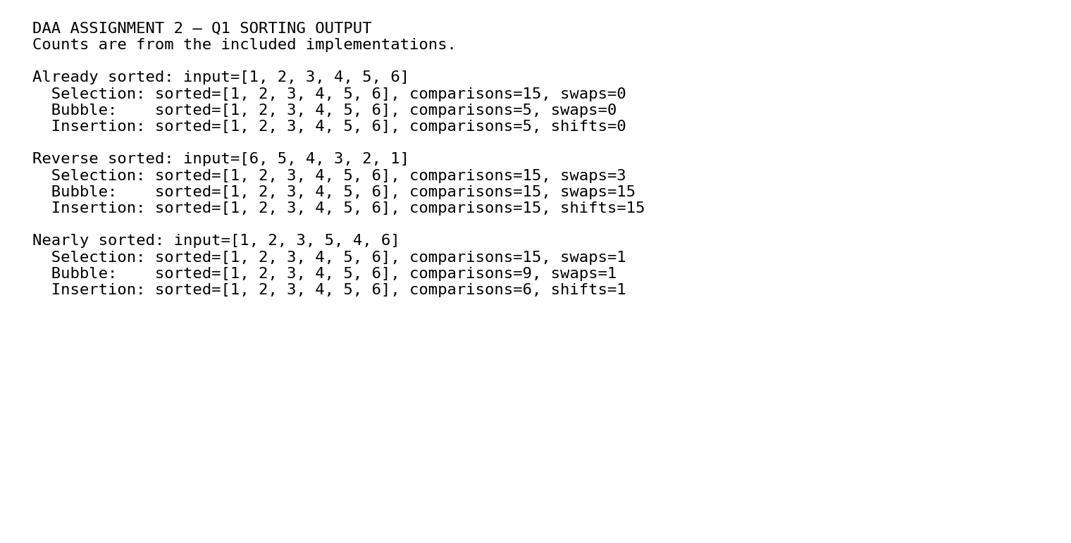
Figure 1. Output panel for the three sorting algorithms. The counts use the exact implementation conventions described in the report.

Q2 – Expanded sequential-search explanation
Sequential search checks records from the first item to the last. If the requested tool is first, it takes one comparison; if it is last, it takes n comparisons. If the tool is absent, all n records are checked. For an equally likely successful target in a list of n items, the average number of comparisons is (n+1)/2. If the list is frequently searched and contains many records, indexing by Tool ID or using a hash table can substantially reduce lookup work.

Q3 – String-matching output screenshot
Brute-force matching aligns the pattern at each possible text position and compares characters from left to right. A mismatch stops that alignment; a full match stops the entire search. Repeated prefixes can cause many characters to be compared again at nearby alignments.
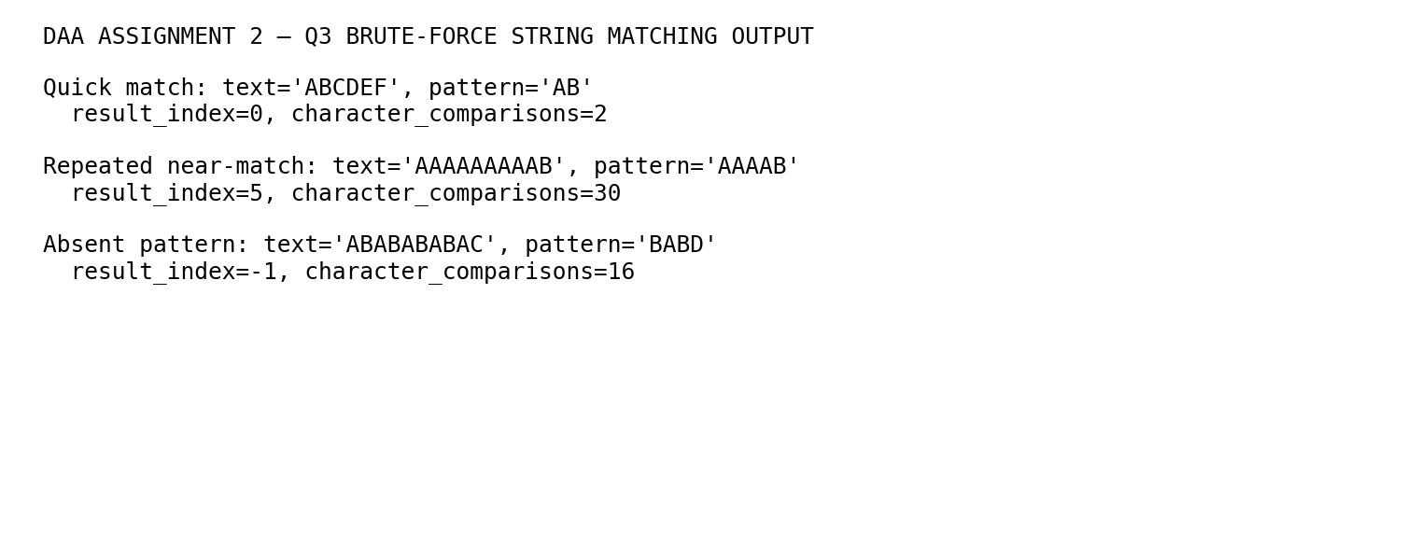
Figure 2. Character-comparison counts from the three text-pattern test cases.

Q4 – Closest-pair output and growth
There are n(n−1)/2 unique pairs because the pair (A,B) is the same as (B,A), and a point is not paired with itself. The inner loop begins at i+1 to avoid duplicate comparisons. The following output panel shows the closest pair and exact number of pair checks for three datasets.
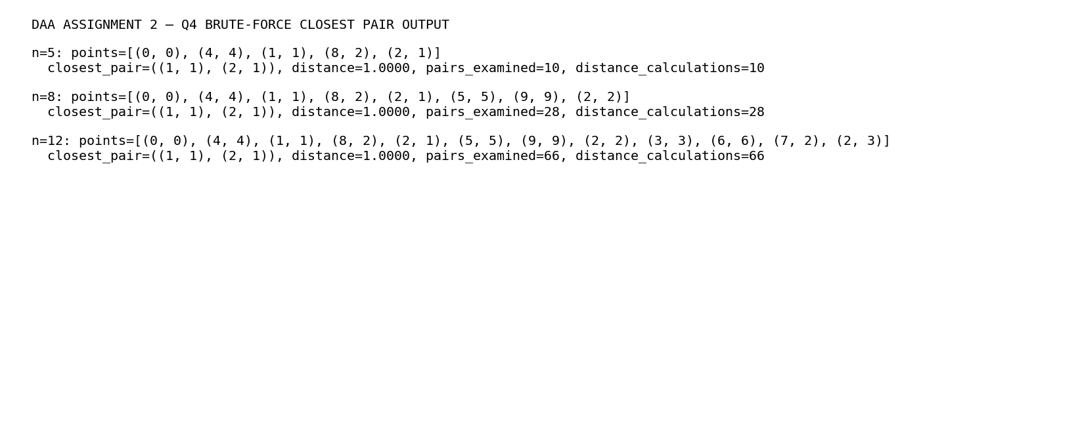
Figure 3. Brute-force closest-pair results.
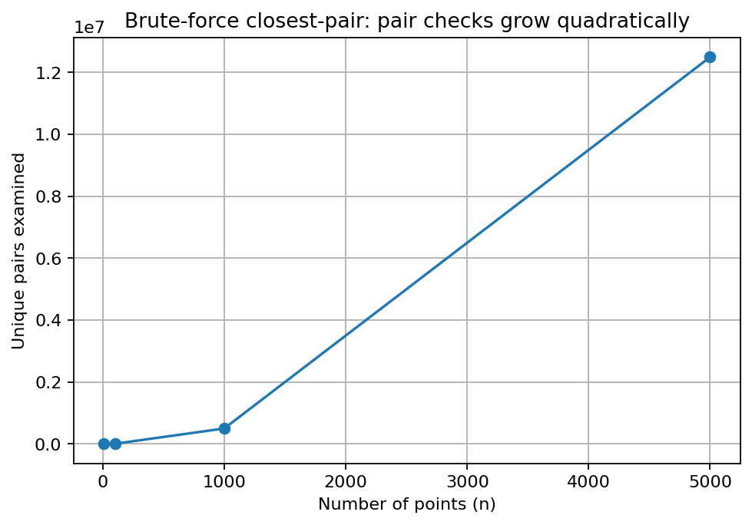
Figure 4. Mathematical growth of pair checks. The curve steepens because pair count is quadratic.

Q5 – Convex-hull boundary visualizations
A convex hull is the smallest convex polygon containing every point. For each candidate segment, the cross-product sign tells whether a point is to the left of the directed line, to the right, or collinear. If points appear on both sides, the segment cannot be a supporting boundary edge. The plots below show the intended hull boundary for the two test sets.
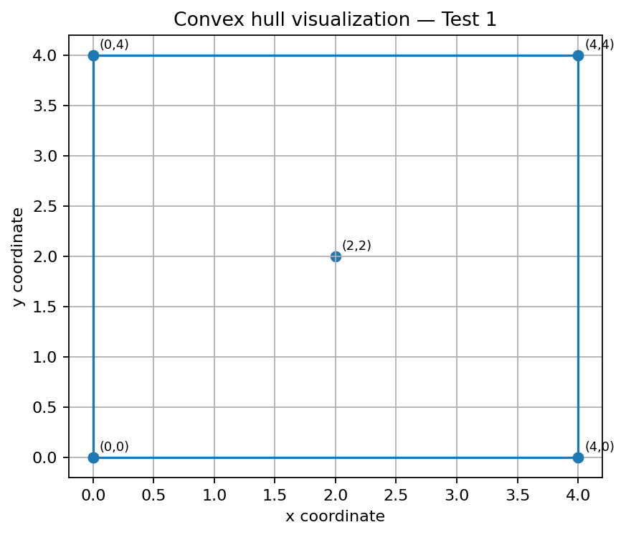
Figure 5. Convex-hull test configuration 1.
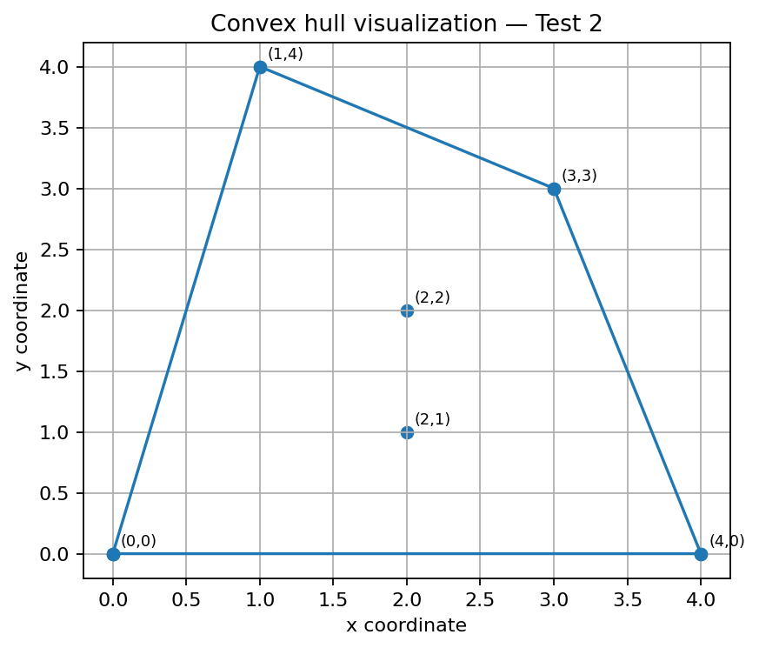
Figure 6. Convex-hull test configuration 2.

Q6 – Exhaustive-search output screenshot
For n packages there are 2^n subsets, including the empty subset. Every subset is checked for weight feasibility, then feasible subsets are compared by total value. The four-package test has 16 subsets. With capacity 8, packages B and D have total weight 8 and total value 12.
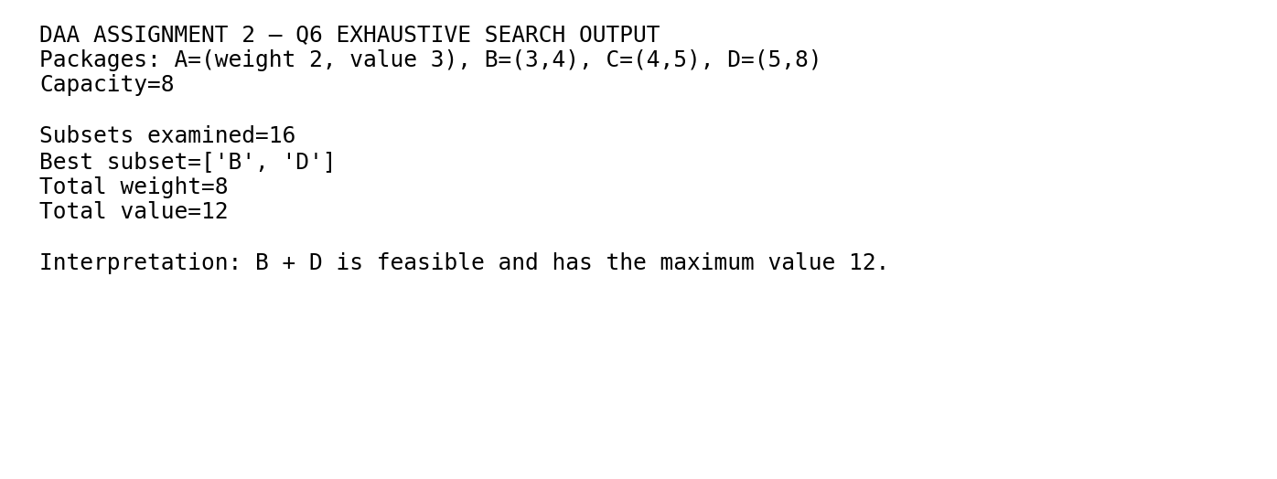
Figure 7. Exhaustive-search result for the small knapsack instance.

Q7 – Expanded redesign validation plan
The proposed closest-pair redesign uses divide and conquer: sort points, solve each half recursively, then inspect a narrow strip near the dividing line. This avoids checking every pair across the entire dataset. For a fair validation, use exactly the same generated points for both algorithms, verify that the minimum distances agree, and record distance-calculation counts. Do not claim measured execution-time improvements until you have actually timed both implementations.

Additional pseudocode: sequential search
sequential_search(records, target_id):
comparisons = 0
for each record in records:
comparisons = comparisons + 1
if record.tool_id == target_id:
return record, comparisons
return NOT_FOUND, comparisons

Suggested viva questions
- Why does selection sort make the same number of comparisons for sorted and reverse-sorted inputs?
- Why is insertion sort a good fit when most records are already ordered?
- How many comparisons does sequential search make when the target is absent?
- Why can brute-force string matching repeat comparisons?
- Derive n(n−1)/2 for the number of unique point pairs.
- What does the cross product tell you in the convex-hull test?
- Why does exhaustive search examine 2^n subsets?
- What is the key trade-off of divide-and-conquer closest pair compared with brute force?

